Speech, Rhetoric, and Debate
2018-2019
Ms. Whitney

Email: Rachael.Whitney@asu.edu
Class Website: rwhitneyasuprep.weebly.com
Classroom: A215

Introduction
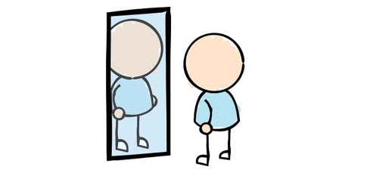
Welcome to Speech, Rhetoric, and Debate! The core purpose of this class is for students to become stronger speakers, critical thinkers, and writers. To do this, students will write and present speeches, engage in formal and informal debates, and write argumentative papers. While public speaking is scary for many people, this class if focused on growth and building skills by experiencing public speaking often and in different contexts. While everyone comes to class with different comfort levels and skills, our goal is to improve through practice and learning techniques for speaking and writing.

Learner Objectives

- Students will become proficient in the 5 techniques of public speaking (public speaking).
- Students will utilize best practices in creating visual aids for speeches (visual aids).
- Students will craft formal and informal argumentative writing (argumentative writing).
- Students will lead, critique, and participate in group discussions and debates on current event issues (debate and current events).
- Students will use rhetorical devices and modes of persuasion to create coherent, articulate, and persuasive speeches (rhetorical knowledge).
- Students will develop knowledge of attitudes and behaviors in professional and academic environments (professional knowledge).
- Students will practice narrative and personal writing to improve communication and writing skills in a variety of contexts (narrative writing).

Class Website Policy

The class website is the hub of information for students and parents/guardians for this class. Please check the website regularly for information on assignments and presentations. The lesson plans, articles, and any attachments will be on the website. Before asking for any class materials or schedule, please check the website first. My website is rwhitneyasuprep.weebly.com.

Cell Phone Policy

Cell phones are not permitted in class unless a student is given permission. Please turn off/silence all cell phones before class begins. Cell phones should not be visible from the beginning to end of class. If there is an emergency reason for use of cell phone, please discuss with me the use of a cell phone before class begins.

Plagiarism and Academic Honesty

Plagiarism, the use of someone else’s materials, words and/or ideas without giving proper credit, will not be tolerated. Plagiarism, even unintentional, is a serious form of cheating and can endanger a student’s academic reputation and, possibly, future career.

Effort Grades

Students will receive effort grades for assignments on a regular basis. These effort grade assessments will not affect overall grades/final grades for the class. These effort grades are intended to provide feedback to students on if and how students can increase effort while in class. These effort grade assessments will be tallied at the end of each quarter to become the end of quarter effort grade.

Classroom Expectations

- Be respectful to your peers, your teachers, and yourself. Treat others with kindness above all else.
- Come to class prepared with any materials you need to be successful.
- Make sure your uniform meets ASU Prep standards.
- Listen to all instructions before getting started on class work.
- Try your best but don’t be afraid of mistakes. Learning from our mistakes is one of the best ways to become better speakers and critical thinkers!
- Leave the classroom clean. Pick up any trash or miscellaneous items before you leave.

Classroom Materials

Please have the following materials for class by August 6. If you need assistance in obtaining these items, please talk to Ms. Whitney.

- Composition Notebook
- Black and/or blue pens
- Pencils
- 3 x 5 index cards (for speeches and bell work)
- Folder
- Loose leaf paper

Syllabus Form: Speech, Rhetoric, and Debate
Due August 6
Please have your parent/guardian fill out and return this form to class on or before Monday, August 6.

Student Name _______________________________

Primary Contact _____________________________

Relationship to Student _______________________

Phone Number ______________________________

Email _______________________________________

Is there anything you would like me to know about your family or student?
___________________________________________________________________________________________________________________________

I have received and read the syllabus for Speech, Rhetoric, and Debate.

Parent/Guardian Signature __________________________________________

Student Signature __________________________________________________

